West Coast Hybrids 38mm H / I / J Motor System
High Powered Hybrid Rocket Motor

READ ALL INSTRUCTION CAREFULLY PRIOR TO USE

West Coast Hybrids has strived to develop the most Simple, Safe and Cost Efficient system on the market to date. All parts of the motor system are manufactured with only the highest quality materials by means of CNC lathes and checked in temperature-controlled environments to maintain the highest possible standards. Our motors use a unique blow-down injection system and utilize a multiple case design with interchangeable parts between impulses.
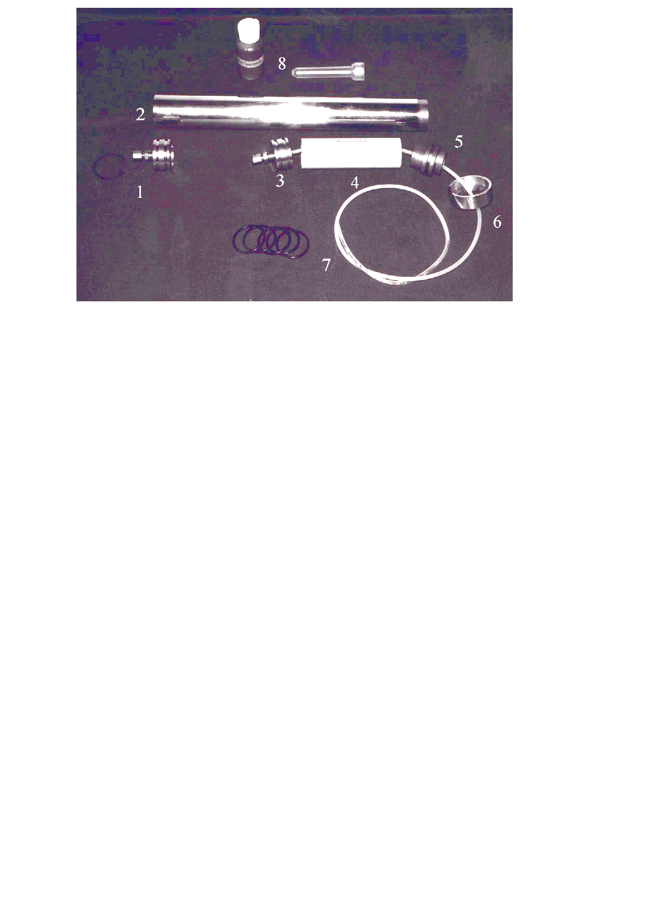
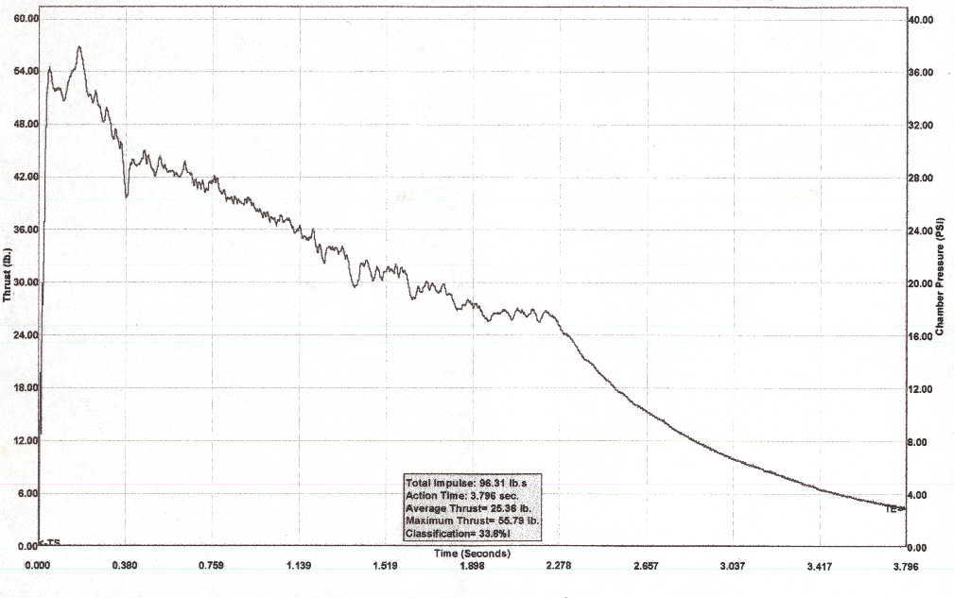
H-70/178 Fill Hose 1/ 8
H-90/170 Fill Hose 5/32
I-110/412 Fill Hose 5/32
I-145/428 Fill Hose 3/16
J-140/664 Fill Hose 3/16
J-200/667 Fill Hose 1/ 4

Figure # 1 Motor Components

Motor Components:
1: Forward Closure, Vent and C-clip (5) Nozzle
2: Case (“H” shown) (6) Nozzle retainer
3: Piston and Injector (same as # 1) (7) O-rings (left) / Fill hose (right)
4: Fuel Grain
Note: Assembly instruction between impulses the same. Piston and forward closure same part. Use appropriate injector for impluse.

Important Notice: Compliance with Federal, State, Provincial & Local Laws and Regulations is mandatory. Law strictly prohibits Sale to Individuals Non-Certified or under the age of 18. Canadian Association of Rocketry “Safety Code” and the Tripoli Rocketry Association “Safety Code” procedures must be strictly adhered to at all times. Consult authority having jurisdiction prior to use.

Safe Handling: Motor must vent liquid nitrous oxide prior to firing. Never fire motor if nitrous supply tank exceeds 900psi. Do not inhale Nitrous Oxide or products of combustion. Non-Medical grade Nitrous Oxide contains Sulfur Dioxide, which is meant to induce vomiting, In the event of over-inhalation remove victim to fresh air. If breathing has stopped properly trained personal should begin artificial respiration. Seek immediate medical attention. Stay within safety guidelines as to “Safe Distances” as per the Canadian association of Rocketry and Tripoli Rocketry association. Never stand near motor while filling, venting or firing. In the event of a misfire, vent tank by means of a remote dump or allow tank a minimum of 20 minutes to vent. Once venting is complete always approach motor surfaces with caution as the motor case and surrounding area can be extremely cold and cause “frostbite”. If cryogenic liquid or cold boil-off gas contacts skin or eyes, frozen tissues should be flooded or soaked with tepid water (105-115F: 41-46C) Do not use hot water! Frostbite, which results in blistering or deeper tissue freezing, requires immediate medical attention. Never store nitrous oxide near flammable or combustible materials especially petroleum-based oils and greases. Use only fluorinated lubricants for assemble process such as (Krytox® 3M Dupont) or silicone DI-electric lubricant. Nitrous oxide is stored at very high-pressure (on average 750psi) take appropriate measures to ensure safe handling practices with gas storage cylinders. West Coast Hybrids recommends leasing gas cylinder from a licensed gas cylinder supplier, as their condition is regularly checked. Caution: surfaces of motor hot after firing.

Required Items not included: The following items are required for the safe assembly and operation of the system but are not included in this kit: (1) Nitrous oxide (2) Tools: 3/8,7/16,1/2 wrenchs, small snap ring pliers and (3) Wire stripers (4) 1 roll of 3/4 masking tape (5) Monotube Fill System with West Coast Pyro-free add-on. See attached “Vent Instruction” sheet for routing of West Coast remote vent kit prior to flight.

Nitrous Oxide Properties N2O:
1: Appearance and Odor / Colorless gas / slightly sweet odor
2: Boiling point / at 1 ATM -127.2F (- 88.5C)
3: Freezing point / at 1 ATM –131.5F (-90.9C)
4: Gas density (1B/cu.ft) at 68F (20C) 1 ATM 0.1151
5: Liquid density at –128F (-89C) 1 ATM 76.54lb/ft3
6: Specified gravity (air=1) at 68F (20C) ATM 1.53
7: Vapour pressure at 81.3F (27.4C) 882psia (60ATM)

ASSEMBLY PROCESS
Read and Follow all steps. Any altering or modification of components can cause property damage or result in serious personal injury. Failure to follow these instructions will void all warranty!
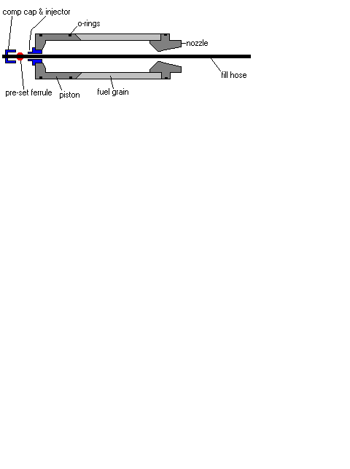

Figure # 2: Cross-section Injector assembly

STEP 1: Case: Choose appropriate case by impulse. Closely inspect case for any signs of damage or flaws. If found, return kit to Dealer or Manufacturer. Check to ensure C-clip grove is free from any foreign debris. Install internal C-clip if not previous installed in forward end of case. Be sure to install C-clip with rounded edge towards forward closure. (Note: white dot on C-clip away from forward closure)

STEP 2: Forward Closure: Apply a small amount of lubricant to the threads and install remote vent in flat side of forward closure, if not previous installed. Install two O-rings (supplied). Apply lubricant to the O-rings and first inner inch of the Aft case or threaded end. Slide the forward closure flat face first into the Aft end of the case (this is best done by a slight twisting of the case while holding the closure) taking care not to damage O-rings. Slide piston to opposite end to rest on C-clip. A tool is easily fabricated from a 36” length of 1” PVC aids in pushing the closure to the opposite end. This tool is also used in the post firing to remove the closure.

STEP 3: Piston: Choose appropriate injector & fill hose by Average Impulse Guide Figure # 1 . (Important Note: Do not fire motors with NON Certified configurations, as serious motor damage can and will occur SEE FILL HOSE CHART) Apply a small amount of lube to the injector threads. Install injector in flat side of piston with 7/16 wrench hand tight. Install two O-rings supplied. Select appropriate filler hose for impulse with pre-set ferrule and slide hose through injector so ferrule comes to rest on injector, (refer to Figure # 2). Apply compression cap and tighten with appropriate wrench one 1/4 turn trim off excess hose on compression cap side. (Ferrules has been pre-set do not attempt to crush further) Apply a small amount of lube to the cup side of the piston to aid in cleaning.

STEP 4: Pyro-free Stem & Igniter Preparation Choose appropriate stainless steel coaxial fill stem. ( Refer to stem selection chart ) If stem has been previously used, clean stem with stainless steel wool. Take appropriate nozzle (refer to Nozzle selection chart / Note: be sure nozzle is installed with convergent side towards the top of the motor ( refer to nozzle diagram ) Install O-ring. Be sure to install nozzle on fill stem prior to motor assembly or igniter preparation, be sure to install nozzle with divergent angle towards stem nut. Igniter Preparation: Take a 16” length of 24 gauge single strand wire (supplied) Bare both ends of wire with appropriate wire stripping tool approximately 1/2 per end. Take fine steel wool ( supplied ) Steel wool is used to create “Igniter Patch” Create igniter patch by stripping off a small section of steel wool from the supply. The igniter patch should be approximately 2”inches long by 3/4 inch wide, and is formed by pulling the steel wool into shape. The patch should not be to thick approximately 1/6” inch thick and light should be clearly visible through the steel wool. Take the igniter wire and the steel wool patch, lie the patch across the shielded portion of the wire next to one of the bared ends. Bend the igniter wire over 90 degrees upon it’s self to hold the patch in place. (refer to figure # 3 ) Take stem and igniter IMPORTANT NOTE: Make sure that the shielded portion of the wire is towards the stem, wrap the steel wool patch tightly around the top of the stem and apply a small piece of 3/4 “inch masking tape to retain the patch to the top of the stem. Next, starting at the top just under the igniter patch take a small strip of tape and retain the igniter wire to the stem by spiraling the tape around the stem. (refer to figure #4 ) Run igniter wire out through nozzle throat.

Stem selection Chart:
G / H / I : Average 80 to 110 Newtons /// Stem outside diameter . 250” or 1/4 inch 6. 35mm

I / J : Average 140 to 160 Newtons /// Stem outside diameter . 313 or 5/16 inch 8. 00mm
MAX/J : Average 180 to 217 Newtons /// stem outside diameter . 375 or 3/8 inch 9. 52mm

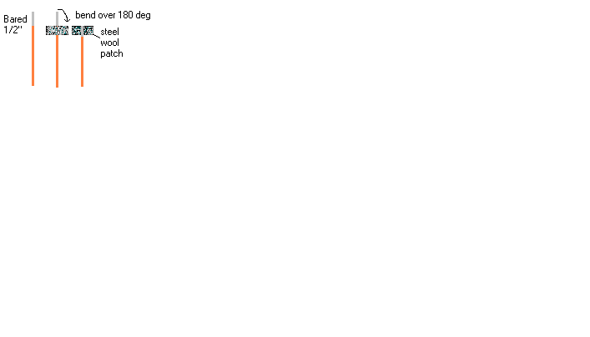
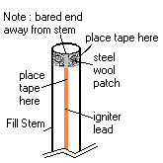

Figure # 3: Igniter Patch Figure # 4: Igniter installation

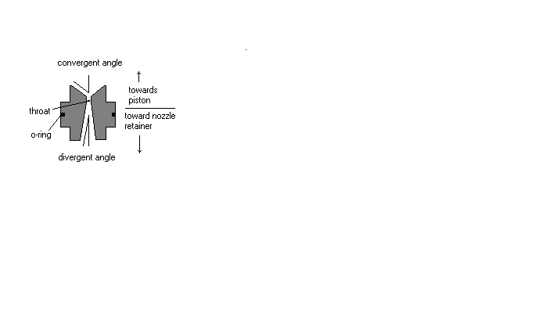

Nozzle Diagram
STEP 5: Final assembly: Take appropriate fuel grain for impulse, apply a small amount of lubricant to internal nozzle end. Slide the fill stem with the igniter up through the fuel grain and slip the nozzle into the grain ( Arrow on fuel grain should point towards top of fill stem and piston ) now install piston the by slipping the nylon fill hose down through the stainless stem. Be sure the interference angle on the piston and interference angle on the grain intersect one another. Apply lubricant to all O-rings installed on the piston & nozzle. Prior to slipping internal components inside apply lubricant to internal one inch surface of Aft case end. Using the fuel grain slide the piston into place and with a slight twisting motion push the nozzle into place. Check to assure threads on aft case end are free from dirt and debris apply a small amount of lube to internal nozzle retainer threads. Pass igniter lead and fill hose through

nozzle retainer and install the retainer, DO NOT OVER TIGHTEN! Nozzle Retainer should hand tight only. Be sure to never stand near rocket while filling venting or firing.

STEP 6: Fill And Fire sequence: Lower rocket onto pad, Do not allow weight of rocket to rest on fill stem protruding from motor. Do not twist stem once installed in chamber. Slip the nylon fill hose through the stem base. While holding the stem tighten fill stem nut to fill stem base ( Do not over tighten ) Make sure rocket weight is taken by a “stand off”. If using West Coasts Pyro-free Fill Stem Stand. Slide the stem up until stem comes into contact with the piston at the top of the chamber. Now using the Nozzle Retainer as a reference point lower the stem, approximately 1/4 to 3/4 of an inch from the top of the chamber. (refer to Figure # 7) Do not fire motor if stem is in contact with Piston. Connect nitrous fill hose to appropriate monotube fill system with West Coast’s Pyro-free ADD-ON, connect igniter lead to high amperage positive lead. Be sure to clean connection between stem and negative lead with stainless steel wool if stem has been use prior. Check that both Oxygen and Nitrous fittings on the stem base are tight and attached correctly. Check oxygen supply pressure is set between 25-35 PSI on the Oxygen regulator. Please contact us for a free copy of plans to build your own ground support equipment (Note: basic stem construction in figure # 8). Be sure that the fill system uses only oxidizer friendly components such as solenoids, gauges, valves and fittings, never use petroleum based lubricants or non-fluorinated lubricants on threads that will be in contact with oxygen or nitrous oxide (explosions can result). Always make sure nitrous oxide supply tank is kept at a safe distance from the motor approximately 5-10 feet. (Check pressure to ensure supply tank is below 900 PSI. If beyond 900 PSI, cool bottle by placing it within water or wrapping bottle with wet cloth. Always use an oxidizer friendly pressure gauge on nitrous supply tank. NEVER FIRE MOTOR IF SUPPLY PRESSURE EXCEEDS 900PSI). Always fill motor by remote means. Never stand near motor while filling, venting or firing. During the filling procedure of the motor, if vapor is noticed venting from any area other than the vent hose stop filling immediately dump oxidizer remotely and re-tighten necessary connection or replace Ferrule. Filling should take approximately 5 -15 seconds depending on case size and ambient temperatures. Once nitrous oxide can be seen venting in a steady liquid stream from the remote vent tube stop filling. Count down can commence with a loud audible 5/4/3/2/1 ( Never fire motor unless a heavy visible stream of nitrous can be seen venting ) . In the event of a misfire, by means of “remote dump” vent the tank to atmosphere, or allow tank a minimum of 20 minutes to vent through remote vent hose. Never approach motor with oxidizer loaded. If the motor does not vent a noticeable steady stream of liquid, do not fire motor as flashback can occur causing serious property damage or personal injury. Always take care as any surfaces in contact with nitrous can be extremely cold and cause frostbite. (Note: fill motor only when it can be fired immediately, never allow motor to sit and vent oxidizer // Note: In the event of a miss-fire completely disassemble motor and repeat assembly process)

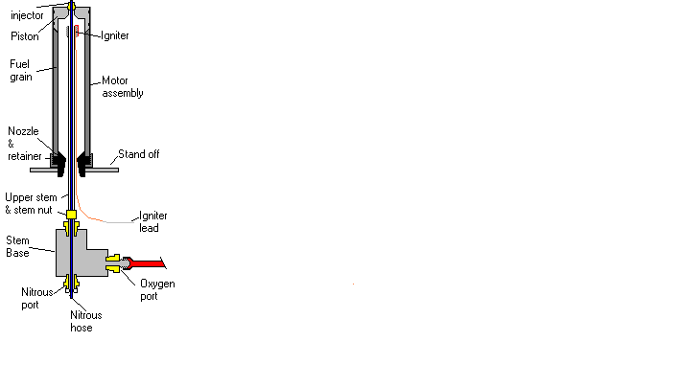

Figure # 6 Chamber with Stem & Igniter installed / Note oxygen & nitrous ports

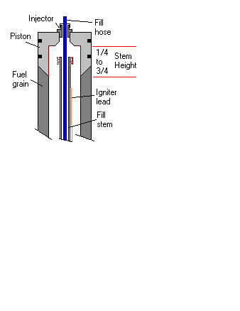

Figure # 7 Stem height in chamber

Nozzle Identification Chart:

G / H / I : Average Impulse 80 - 110 Throat Diameter . 313 or 5/16”

I / J : Average Impulse 140 - 180 Throat Diameter . 375 or 3/8”
MAX/J : Average Impulse 200+ Throat Diameter . 437 or 7/16”
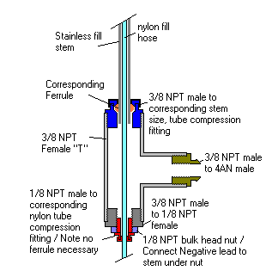

Figure # 8: Basic stem construction

STEP 7: Disassembly / Care and Cleaning / Post Firing: In the event that the motor cannot be fired, remotely dump oxidizer if loaded. For disassembly carefully remove the C-clip retaining the Forward closure, using a 36” length of 1” inch PVC pipe push the internal components out through the Aft closure end of the motor. Make sure that the Nozzle does not drop, as damage can occur. Carefully inspect all components for signs of damage or ware. If such conditions exist, discontinue use. Allow motor assembly to COOL COMPLETELY prior to cleaning. Remove all O-rings and clean groves. Always inspect nozzle for sign of throat erosion or any signs of damage to surface or O-ring sealing area. On average nozzles will last 5 - 10 firing, replace if any signs of cracks of ware exist or throat becomes enlarge as to inhibit motor performance. Clean and inspect threads on case and nozzle retainer. Never leave motor assembled without cleaning, prior to storage. Rinse all parts with warm soapy water or mild water base solvent and wipe off with clean dry cloth or paper wipes. If water is not available use infant wipes or clean dry cloth. Care taken here should provide years of service from your West Coast Hybrid’s Ultra 38 hybrid ® Motor System.

West Coast Hybrids, new Pyro-free Coaxial fill stem has proven to be one of the most simple and reliable completely Pyrotechnically free ignition sequences. West Coast Hybrids uses standard “off the self” components to build our stems, although we highly rework these products for our Fill Stem Stand, a Fill Stem can be easily manufactured by a parts list available apon request. Please note we also offer a complete FREE set of plans on how to build both Ground Support Equipment and the Pyro-free fill stem. (Note : Refer to figure # 8 )

Product disclosure & Warranty: West Coast Hybrids (“WCH”) certifies that it has exercised reasonable care in design and manufacturing of its products. After opening this package reading the instruction and product disclosure you acknowledge that you have read, understand and agree to the terms and conditions contained herein. If you do not agree to the terms and conditions of this warranty and disclosure, please return the unused product in it’s original packaging, prepaid to your dealer or manufacture for exchange or credit. WCH does not assume any responsibility for injury or property damage resulting from the improper use of its products. The buyer assumes all risks and liabilities by accepting and use of WCH products. No warranty expressed or implied in regards to WCH products. All replacement or repair of products is at the discretion of WCH or an authorized representative and must be accompanied by a sales receipt within one (1) year from the date of original sale. Warranted items / Components: Case bulging, burn through or blistering. Ejection of forward or aft closures, Failure of Piston or Forward closure to pressurize. Non Covered / Components: Ware or degradation of Case anodizing, normal wear of graphite nozzle, damage to C-clip grove due to improper tool use, failure resulting from O-ring blow-by, miss-use or modifying of any components other than there intended use, failure due to improper assembly. Reloads and Reload kits warranted: Case failure due to fuel grain burn through Non Covered Reloads: Failure to ignite, failure due to improper assembly or modification in any way to reload. Any comments or concerns please feel free to contact us at: www.westcoasthybrids.com or via our tech line (250) 884 - 8518

All Contents © 2002 West Coast Hybrids

